

Borrower’s Authorization Form

I, Brian Morman, hereby authorize Radian Title Services, to obtain the following information/documentation on my behalf;
Payoff Amounts/Statements, Subordination Requirements/Agreements, and any other information or documentation mentioned on this form. It is understood that a photocopy of this form will also serve as authorization.

Date of Request: 11/25/25

Property Address: 913 Penny Ln, Ballwin, MO 63011

Borrower
Name (Signed): 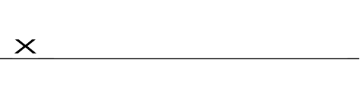 Date:__11/25/25__
Name (Print): _Brian Morman____________

Co-Borrower
Name (Signed):______________________ Date:______________
Name (Print):________________________

